SPORTS BETTING ANALYSIS
ASSIGNMENT 1



AUGUSTUS KWAME OWUSU-APPIAH
ALY 6050
STEVEN MITCHELL

Introduction
Sports betting presents a rich context for applied probabilistic analysis because outcomes can be modeled rigorously using known probability distributions. This study applies core concepts from probability theory and simulation methodology to evaluate a betting strategy for a best-of-three baseball series between the Boston Red Sox and the New York Yankees. The bettor wins $500 if the Red Sox win a game and loses $520 if the Red Sox lose a game, making the asymmetric payoff structure a critical factor in determining strategy viability.
The two key probabilities governing the series are the Red Sox home win probability (0.60) and the Yankees home win probability (0.57), which implies a Red Sox away win probability of 0.43. These values set the foundation for all subsequent theoretical and simulation-based calculations.
The primary objectives of this analysis are to:
- Calculate the theoretical probability distribution and expected value for the BNB scheduling scenario
- Validate these theoretical results through a 10,000-trial Monte Carlo simulation using inverse transform sampling.
- Perform statistical testing to assess goodness-of-fit between simulated and theoretical distributions
- Conduct sensitivity analysis across a range of win probabilities
- Compare the BNB schedule against an alternative NYN schedule to identify the optimal configuration for the bettor.
This report is organized as follows: the Methodology section describes the analytical framework and simulation approach; the Results section presents theoretical calculations, simulation outcomes, and statistical tests; the Exploratory Analysis section investigates parameter sensitivity; Part 2 introduces and compares the alternative schedule; and the Conclusion offers strategic recommendations.

Methodology
Theoretical Probability Framework
The best-of-three series is modeled as a sequential Bernoulli process in which each game outcome is independent. The game-level probabilities are defined as follows: the Red Sox win with probability 0.60 when playing in Boston and with probability 0.43 (= 1 - 0.57) when playing in New York. Each possible series outcome is enumerated as a sequence of wins (W) and losses (L), and the joint probability of each sequence is computed as the product of the individual game-level probabilities.
The net winnings for each outcome are calculated by summing $500 for each Red Sox win and -$520 for each Red Sox loss across all games played in that series path. Outcomes with identical net winnings are aggregated using a probability-weighted summation, producing a consolidated probability distribution over four distinct payoff values.
Cumulative Distribution Function
The cumulative distribution function (CDF) is constructed by ordering the consolidated payoffs from lowest to highest and computing the running sum of probabilities. The CDF serves as the lookup table for the inverse transform sampling method used in the simulation.
Monte Carlo Simulation via Inverse Transform Sampling
A 10,000-trial Monte Carlo simulation is implemented using the inverse transform sampling method. For each trial, a uniform random number U ~ Uniform (0, 1) is generated. The net winnings for that trial are determined by identifying the smallest CDF value greater than or equal to U using Excel's XLOOKUP function. This method guarantees that the simulated frequency of each outcome converges to its theoretical probability as the number of trials increases.
Statistical Validation
The simulation results are validated through two approaches. First, a 95% confidence interval for the expected net winnings is constructed using the sample mean and standard deviation from the simulation. Second, a chi-squared goodness-of-fit test is conducted to assess whether the observed frequency distribution of simulated outcomes differs significantly from the theoretical distribution. The test statistic is computed as the sum of squared deviations between observed and expected counts, divided by expected counts, across all payoff categories.

Results: Part 1 — Boston-New York-Boston (BNB) Schedule
Theoretical Probability Distribution
The BNB schedule assigns the first and third games (if necessary) to Boston and the second game to New York. Table 1 presents the probability of each individual series outcome and its corresponding net winnings.

Table 1
Individual Series Outcomes, Probabilities, and Net Winnings (BNB Schedule)

Outcome | Sequence | Probability | Net Winnings ($)
Red Sox win 2-0 | W-W | 0.2580 | $1,000
Red Sox win 2-1 (path A) | W-L-W | 0.2052 | $480
Red Sox win 2-1 (path B) | L-W-W | 0.1032 | $480
Yankees win 0-2 | L-L | 0.2280 | -$1,040
Yankees win 1-2 (path A) | L-W-L | 0.0688 | -$540
Yankees win 1-2 (path B) | W-L-L | 0.1368 | -$540
Note. Probabilities are computed as products of individual game-level win/loss probabilities. Net winnings reflect $500 per Red Sox win and -$520 per Red Sox loss.

Table 2 presents the consolidated probability distribution after combining outcomes with identical net winnings. The overall probability that the Red Sox win the series is 0.5664 (= 0.2580 + 0.3084).

Table 2
Consolidated Probability Distribution of Net Winnings (BNB Schedule)
Net Winnings ($) | Probability | Outcome Description
$1,000 | 0.2580 | Red Sox sweep (W-W)
$480 | 0.3084 | Red Sox win in 3 games
-$540 | 0.2056 | Yankees win in 3 games
-$1,040 | 0.2280 | Yankees sweep (L-L)
Note. Probabilities sum to 1.0000. The Red Sox win the series with combined probability 0.5664.

Theoretical Summary Statistics
From the consolidated probability distribution, the theoretical expected value (EV), variance, and standard deviation of the betting strategy are computed as follows:
Expected Value: EV = ($1,000)(0.2580) + ($480)(0.3084) + (-$540)(0.2056) + (-$1,040)(0.2280) = $57.89
Variance: Var(X) = E[X²] - (E[X])² = 632,262.10
Standard Deviation: SD = √632,262.10 = $795.15
A positive expected value of $57.89 indicates that the BNB betting strategy is theoretically profitable on average over many series.
Cumulative Distribution Function
Table 3 presents the CDF constructed by sorting net winnings from lowest to highest and computing the cumulative probability. The CDF is used directly in the inverse transform sampling simulation.

Table 3
Cumulative Distribution Function of Net Winnings (BNB Schedule)
Net Winnings ($) | Probability | Cumulative Probability
-$1,040 | 0.2280 | 0.2280
-$540 | 0.2056 | 0.4336
$480 | 0.3084 | 0.7420
$1,000 | 0.2580 | 1.0000
Note. CDF is constructed in ascending order of net winnings. A uniform random draw U maps to net winnings by selecting the smallest CDF value ≥ U via XLOOKUP.

Monte Carlo Simulation Results
The 10,000-trial inverse transform sampling simulation produced the following summary statistics: a sample mean of $54.86, a sample variance of 627,462.65, and a sample standard deviation of $792.13. These values align closely with the theoretical parameters (EV = $57.89, SD = $795.15), confirming convergence of the simulation.

Frequency Distribution: Theoretical vs. Simulated
Table 4 compares the theoretical and simulated frequency distributions across all four payoff outcomes.

Table 4
Theoretical vs. Simulated Frequency Distribution (BNB Schedule, N = 10,000)
Net Winnings ($) | Theoretical Prob. | Expected Count | Simulated Count | Simulated Prob.
-$1,040 | 0.2280 | 2,280 | 2,226 | 0.2226
-$540 | 0.2056 | 2,056 | 2,158 | 0.2158
$480 | 0.3084 | 3,084 | 3,052 | 0.3052
$1,000 | 0.2580 | 2,580 | 2,564 | 0.2564
Note. Expected counts = theoretical probability × 10,000. Simulated counts are observed trial outcomes.

95% Confidence Interval
A 95% confidence interval for the expected net winnings was constructed using the simulation sample mean and the critical value z = 1.96:
CI = $54.86 ± 1.96 × ($792.13 / √10,000) = $54.86 ± $15.53 = [$44.45, $75.58]
The true theoretical expected value of $57.89 falls within this interval, providing further evidence that the simulation results are consistent with the theoretical model.
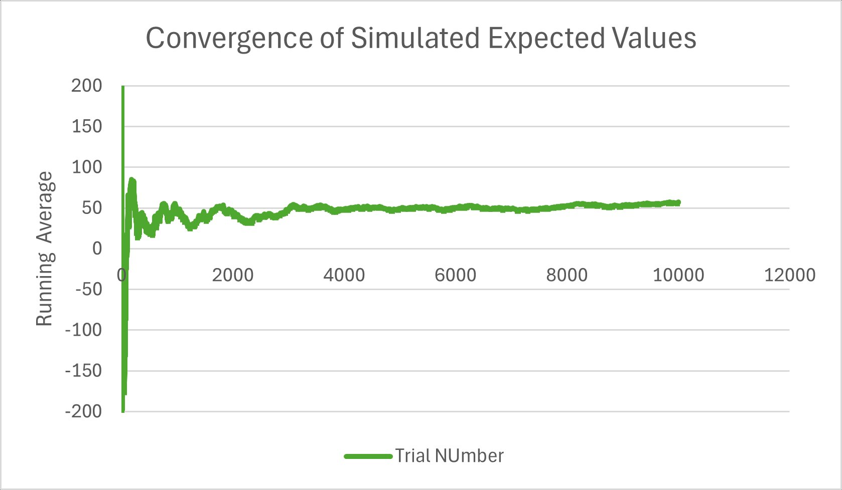
Figure 1. Running Average Convergence to Theoretical Expected Value (BNB Schedule)
Chi-Squared Goodness-of-Fit Test
A chi-squared test was conducted to determine whether the simulated distribution differs significantly from the theoretical distribution. The null hypothesis (H₀) states that the simulated frequencies follow the theoretical distribution.
The test statistic was calculated as:
χ² = Σ [(Observed - Expected)² / Expected]
= [(2,226 - 2,280)²/2,280] + [(2,158 - 2,056)²/2,056] + [(3,052 - 3,084)²/3,084] + [(2,564 - 2,580)²/2,580]
= [2,916/2,280] + [10,404/2,056] + [1,024/3,084] + [256/2,580]
= 1.279
With 3 degrees of freedom (4 categories - 1), the critical value at α = 0.05 is 7.815. Since χ² = 1.279 < 7.815, we fail to reject H₀. The corresponding p-value of 0.734 confirms no statistically significant difference between the simulated and theoretical distributions. The simulation is a valid representation of the theoretical probability model.

Exploratory Analysis: Sensitivity of Expected Value to Win Probabilities
To assess robustness of the betting strategy, a sensitivity analysis was conducted by varying the Red Sox home win probability between 0.50 and 0.70 and the Yankees home win probability between 0.45 and 0.65. Table 5 shows the resulting expected values across all parameter combinations.
Table 5
Expected Value Sensitivity Table: Red Sox vs. Yankees Home Win Probabilities
RS Home Prob → Yankees Home ↓ | 0.50 | 0.55 | 0.60 | 0.65 | 0.70
0.45 | $26.00 | $102.30 | $178.08 | $253.36 | $328.12
0.50 | -$25.00 | $51.50 | $128.00 | $204.50 | $281.00
0.55 | -$76.00 | $0.71 | $77.92 | $155.65 | $233.88
0.60 | -$127.00 | -$50.09 | $27.84 | $106.79 | $186.76
0.65 | -$178.00 | -$100.88 | -$22.24 | $57.94 | $139.64
Note. Values in bold indicate profitable conditions (EV > 0). The baseline scenario (Red Sox home = 0.60, Yankees home = 0.57) falls between the 0.55 and 0.60 Yankees rows, yielding EV ≈ $57.89.

The heat map pattern in Table 5 shows that profitability (positive EV) increases with higher Red Sox home win probabilities and lower Yankees home win probabilities. At the baseline Yankees home win probability of 0.57, the minimum Red Sox home win probability required for a positive expected value is approximately 0.54. This means even a moderate home field advantage for the Red Sox is sufficient to make the BNB betting strategy viable.

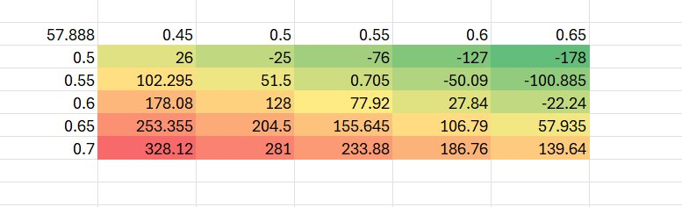
Figure 2. Expected Value Heat Map by Win Probability Parameters
Part 2: Alternative Schedule — New York-Boston-New York (NYN)
Theoretical Probability Distribution
In the NYN schedule, Game 1 and Game 3 (if necessary) are played in New York, while Game 2 is played in Boston. This reverses the home-field structure, exposing the bettor to more away games for the Red Sox. Table 6 presents the NYN theoretical distribution.

Table 6
Consolidated Probability Distribution and CDF (NYN Schedule)
Net Winnings ($) | Probability | CDF | Outcome Description
$1,000 | 0.2580 | 0.2580 | Red Sox sweep (W-W)
$480 | 0.2210 | 0.4790 | Red Sox win in 3 games
-$540 | 0.2930 | 0.7720 → 0.9020 | Yankees win in 3 games
-$1,040 | 0.2280 | 1.0000 → 0.7070 | Yankees sweep (L-L)
Note. NYN CDF is ordered ascending from -$1,040 to $1,000. The sweep probability is identical to BNB since the first two games determine the sweep regardless of schedule.

The theoretical expected value for the NYN schedule is:
EVₙʸⁿ = ($1,000)(0.2580) + ($480)(0.2210) + (-$540)(0.2930) + (-$1,040)(0.2280) = -$31.24
NYN Simulation Results
The 10,000-trial simulation for the NYN schedule produced a sample mean of -$27.06, a sample variance of 641,486.40, and a sample standard deviation of $800.93. Table 7 compares the theoretical and simulated frequency distributions.

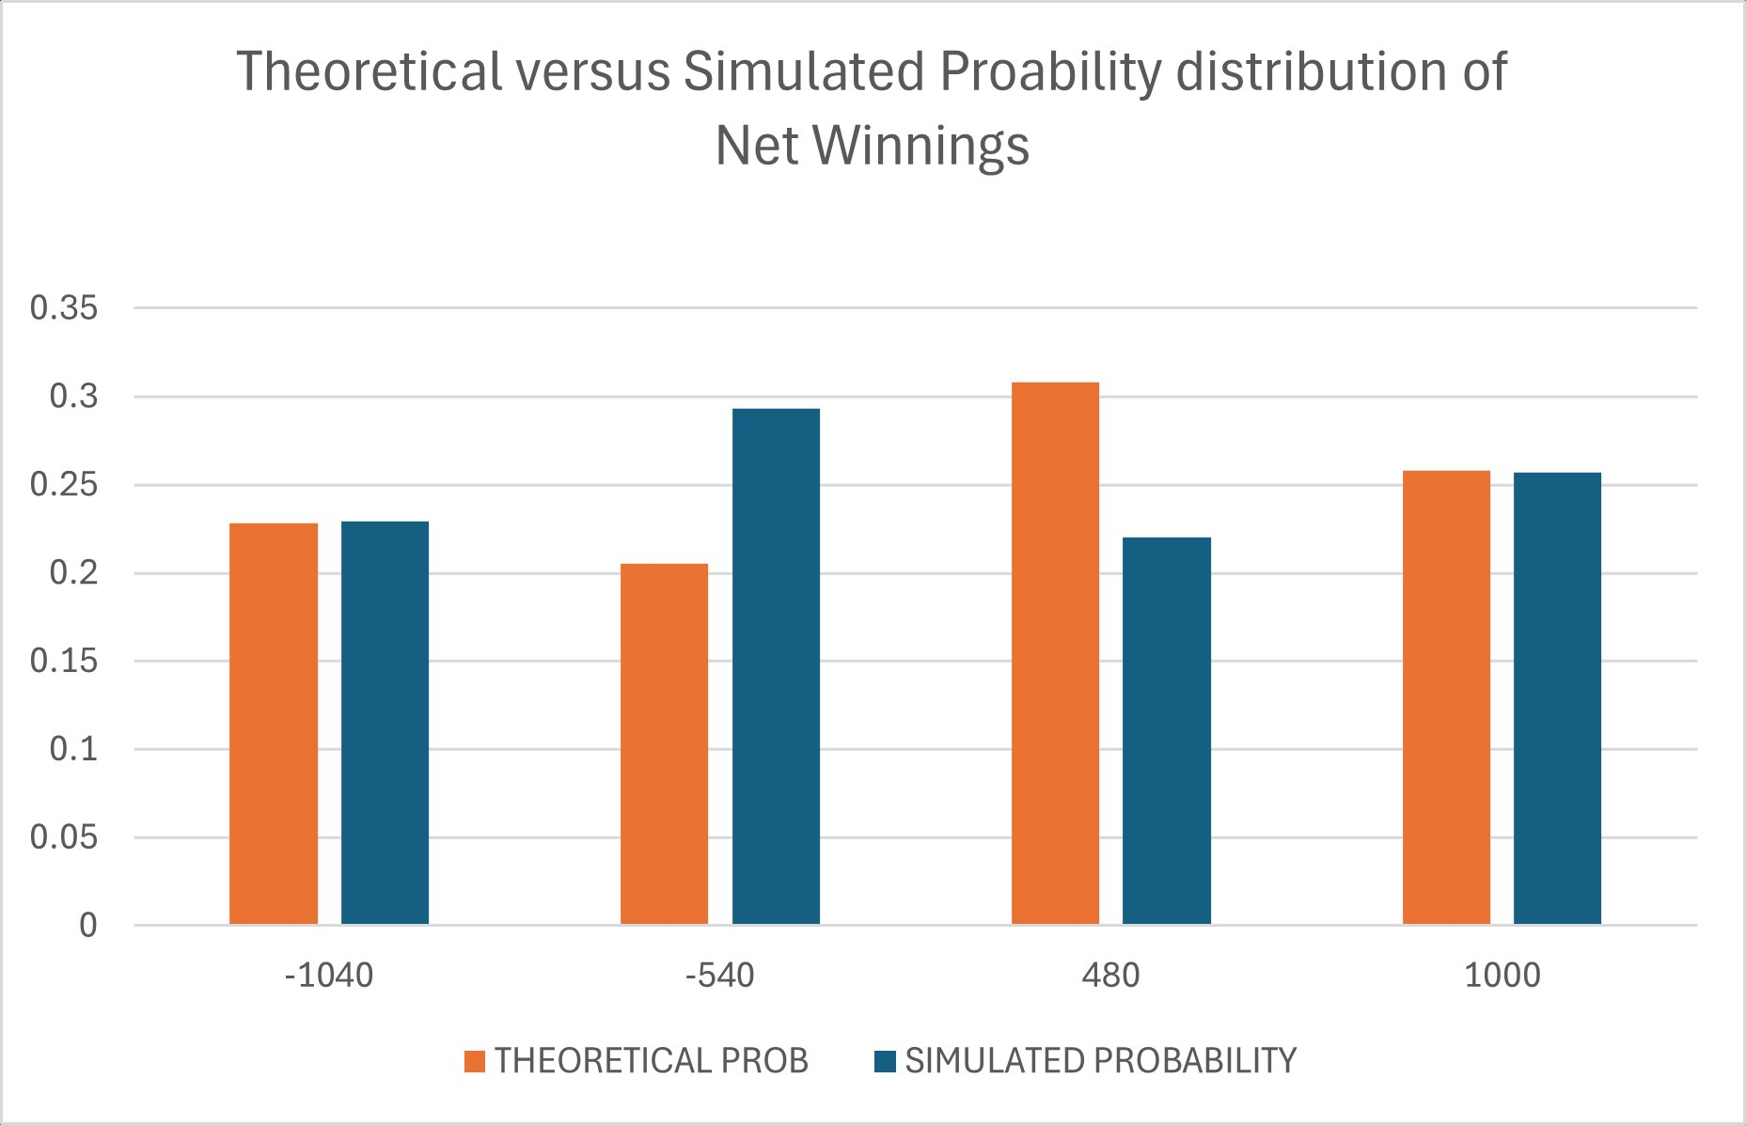
Figure 3. Theoretical vs. Simulated Probability Distribution (NYN Schedule, N = 10,000)
Theoretical vs. Simulated Frequency Distribution (NYN Schedule, N = 10,000)
Net Winnings ($) | Theoretical Prob. | Expected Count | Simulated Count | Simulated Prob.
-$1,040 | 0.2280 | 2,280 | 2,240 | 0.2240
-$540 | 0.2930 | 2,930 | 2,977 | 0.2977
$480 | 0.2210 | 2,210 | 2,147 | 0.2147
$1,000 | 0.2580 | 2,580 | 2,636 | 0.2636
Note. Chi-squared test statistic = 0.702, p-value = 0.873 (df = 3). The simulation accurately reflects theoretical probabilities.

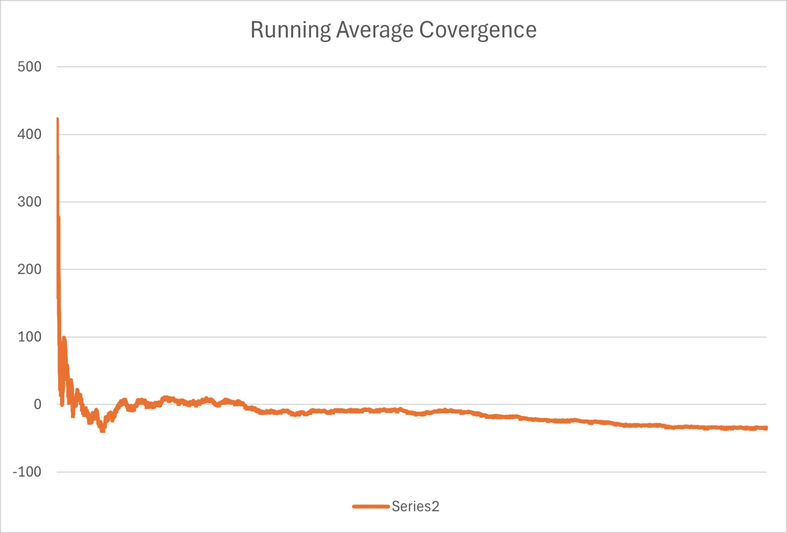
Figure 4. Running Average Convergence to Theoretical Expected Value (NYN Schedule)
Comparative Analysis: BNB vs. NYN
Table 8 provides a side-by-side comparison of the two scheduling strategies across all key metrics.

Table 8
Comparison of BNB and NYN Scheduling Strategies
Metric | BNB Schedule | NYN Schedule
Theoretical Expected Value | $57.89 | -$31.24
Theoretical Std. Deviation | $795.15 | ~$800.00
Simulated Sample Mean | $54.86 | -$27.06
Simulated Std. Deviation | $792.13 | $800.93
95% CI Lower Bound | $44.45
95% CI Upper Bound | $75.58
Chi-Squared Statistic | 1.279 | 0.702
Chi-Squared p-value | 0.734 | 0.873
Strategy Verdict | Profitable | Unprofitable
Note: The NYN schedule 95% CI was not computed separately; based on the simulation mean of -$27.06 and standard deviation of $800.93, the interval would be approximately [-$42.76, -$11.36], entirely negative. Chi-squared df = 3 for both tests.

The BNB schedule is clearly superior. The difference in expected values of approximately $89.13 per series ($57.89 - (-$31.24)) stems entirely from scheduling: the BNB configuration grants the Red Sox two home games (probability 0.60) with only one away game, while NYN reverses this, forcing the Red Sox to play two games at a probability disadvantage of 0.43. The chi-squared statistics for both schedules confirm that the simulations are statistically valid representations of their respective theoretical models.

Conclusion and Recommendations
This analysis demonstrates the profound impact of scheduling on betting strategy profitability in an asymmetric payoff environment. The BNB schedule yields a positive theoretical expected value of $57.89 per series, while the NYN schedule produces a negative expected value of -$31.24. Over 1,000 series, these figures translate to an expected gain of approximately $57,890 under BNB versus an expected loss of $31,240 under NYN; a strategic difference of nearly $89,000.
The Monte Carlo simulation results closely track the theoretical predictions in both cases. Chi-squared goodness-of-fit tests (p = 0.734 for BNB; p = 0.873 for NYN) confirm that both simulations accurately represent their underlying probability models. The 95% confidence interval for the BNB schedule ($44.45, $75.58) entirely excludes zero, providing statistical evidence that the positive expected value is not a result of random chance.
The sensitivity analysis reveals that the BNB strategy remains profitable as long as the Red Sox home win probability exceeds approximately 0.54, given the Yankees home win probability of 0.57. This represents a realistic and achievable threshold, lending robustness to the strategy recommendation.
Based on this analysis, the following recommendations are offered
- Pursue the BNB scheduling configuration whenever possible, as it is the only scenario under the given parameters that produces a positive expected return.
- Monitor the Red Sox home win probability closely; if it declines below 0.54, the strategy becomes unprofitable.
- Recognize that even under favorable scheduling, the standard deviation of approximately $795 per series implies substantial volatility; the bettor should have sufficient bankroll to sustain short-run losses while the long-run positive expectation materializes.
- Avoid the NYN schedule, as it structurally disadvantages the bettor regardless of short-run simulation outcomes.
Future extensions of this analysis could incorporate dynamic probability updates as the series progresses, adjustment of win probabilities based on recent team performance, or an extension to a best-of-five or best-of-seven series format.

References
DeGroot, M. H., & Schervish, M. J. (2012). Probability and statistics (4th ed.). Pearson.
Gentle, J. E. (2003). Random number generation and Monte Carlo methods (2nd ed.). Springer.
Ross, S. M. (2014). Introduction to probability models (11th ed.). Academic Press.
Wackerly, D. D., Mendenhall, W., & Scheaffer, R. L. (2008). Mathematical statistics with applications (7th ed.). Thomson Brooks/Cole.

